
me: ______________________ Class: ______ Time: 55 minutes Total Mark:____/58
Year 7

End of Term 1 Test

2018

Show working and answers on this sheet. Show working in sufficient detail to support your answers. Incorrect answers without supporting reasoning will be allocated zero marks.

Resources: 1 x A4 page of notes (2 sided)
Non Calculator Section
35 mins

Question 1 2 marks

Circle the largest number and underline the lowest number

- -6 -4 9 -12 2

- 0 15 -2 -21 19

Question 2 2 marks

Order the following from lowest to highest:

-2, 6, -6, 3, 1, -1, 0 ____________________________________

Question 3 2 marks

Indicate which is integer is largest by placing either a < or > in between each set of numbers:

- -7 ___ -12 b) -5 ___ 4

Question 4 4 marks

Complete the following:

  - 2 + -3 = __________
- -5 + 2 = __________

- 8 - +3 = __________

  - -12 - -11 = __________

Question 5 4 marks

Use the symbols <, > or = to complete the number sentences.

- 12 + 27 ____ 21 + 18 c) 2² + 4² ____ 5² x 2

- 3 x (2 + 5) _____ 3 x 2 + 3 x 4 d) (3 + 5) – 4 ____ 3 + (5 – 4)

Question 6 2 marks

The minimum temperature in the city of Destiny was -12ºC at 6am. It increased by 5ºC in the next two hours and then increased by 9ºC in the next five hours to reach its maximum. At what time did it reach its maximum temperature and what was this maximum temperature?

Question 7 2 marks

Complete the table.

Index Form | Expanded Form
 | 2x2x2x2
 | 10x10x10x10x10x10
5³

12⁵

Question 8 4 marks
Evaluate the following squares.

Index Form | Evaluate
3²
10²
4²
20²

Question 9 8 marks

Use a factor tree to find the prime factors of 60.

60 225

The Prime Factors of 60= ___________________

The Prime Factors of 225= ___________________

Use the prime factor trees to find the highest Common Factor (HCF) of 60 and 225. __________________.

How do you know that 225 is a square number from it’s prime factors.

Question 10 3 marks
Evaluate the following square roots

- $\sqrt{16}$ =
- $\sqrt{81}$ =
- $\sqrt{100}$ =

Question 11 3 marks

Evaluate

- $\sqrt{3600}$ =

- $\sqrt{0.64}$ =

- $5+\sqrt{49}=$

Question 12 2 marks

  - $\sqrt{20}$ is between which two integers?

Year 7

End of Term 1 Test

2018

Name: _______________________________
Calculator Section
20 mins

Question 15 6 marks

Find the Perimeter and Area of the following shapes. The distance between the dots is 1cm

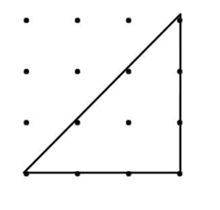
a) b) c)
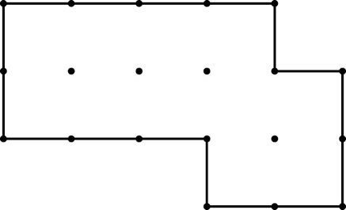
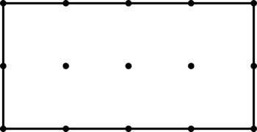

Perimeter = Perimeter = Perimeter =

Area = Area = Area =

Question 16 1, 1, 1, 2, 2 - 6 marks

Find the area of the following shapes. Show your work

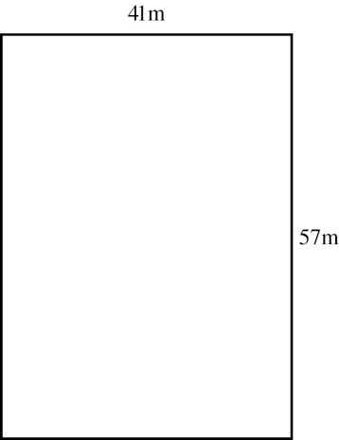
a. b.
5 cm
10 cm
8 cm

8 cm

c. d.
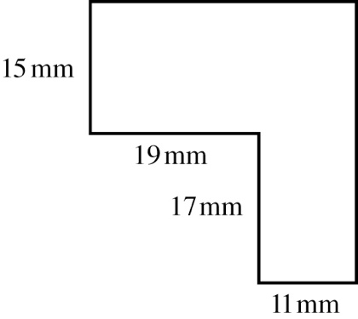
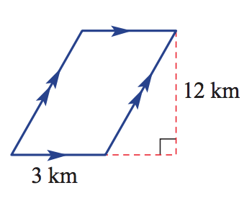
22 mm
30 mm

e.
5 mm

8 mm

10 mm

Question 17 2 marks

Two hundred square tiles, each measuring 10 cm by 10 cm, are used to tile an open floor area. Find the area of flooring that is tiled.

Question 18 2 marks

The area of a triangle is 10 cm2 and its base length is 4 cm. Find its height.

Question 19 4 marks
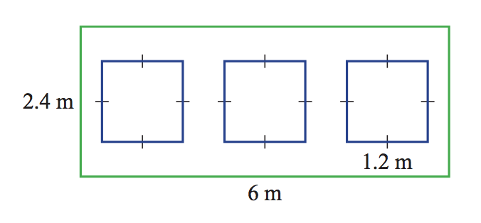
A wall has three square holes cut into it to allow for windows, as shown. Find the remaining area of the wall.

END OF TEST

